
DEPARTMENT OF

COMPUTER

Experiment 3
Student Name:Riya Kashyap UID: 25MCA20033
Branch: MCA-UIC Section/Group: 1
Semester: 2nd Date of Performance:27/1/2026
Subject Name: Technical Training Subject Code: 25CAP-652

- Aim:To implement conditional decision-making logic in PostgreSQL using IF–ELSE constructs and CASE expressions for classification, validation, and rule-based data processing.
- Objective:
- To understand conditional execution in SQL
- To implement decision-making logic using CASE expressions
- To simulate real-world rule validation scenarios
- To classify data based on multiple conditions
- To strengthen SQL logic skills required in interviews and backend systems
- Practical/Experiment Steps:
- Create the required table to store schema name and violation count.
- Insert sample records with different violation values.
- Retrieve data using a SELECT statement.
- Apply searched CASE expression to classify violations.
- Display classification results in the output.
- Alter the table to add an approval status column.
- Update approval status using CASE logic.
- Verify updated records using SELECT query.
- Declare variables inside a PL/pgSQL block.
- Implement IF–ELSE and ELSIF conditions.
- Display messages based on condition evaluation.
- Create a student table for real-world classification.
- Insert student marks into the table.
- Use CASE expression to assign grades.
- Display student name, marks, and grade.
- Apply CASE inside ORDER BY clause.
- Sort records based on priority conditions.
- Verify final output for correctness.
- Analyze results based on business rules.
- Conclude the experiment successfully.
- Procedure of the Practical:

-- Step 0
-- Create table for schema violations
CREATE TABLE schema_violations (
schema_id SERIAL PRIMARY KEY,
schema_name VARCHAR(50),
violation_count INT
);

-- Insert sample data
INSERT INTO schema_violations (schema_name, violation_count) VALUES
('HR_SCHEMA', 0),
('FIN_SCHEMA', 2),
('SALES_SCHEMA', 5),
('PAYROLL_SCHEMA', 9),
('AUDIT_SCHEMA', 15);

--step 1
SELECT
schema_name,
violation_count,
CASE
WHEN violation_count = 0 THEN 'No Violation'
WHEN violation_count BETWEEN 1 AND 3 THEN 'Minor Violation'
WHEN violation_count BETWEEN 4 AND 7 THEN 'Moderate Violation'
ELSE 'Critical Violation'
END AS violation_status
FROM schema_violations;

-- Step 2
-- Add new column
ALTER TABLE schema_violations
ADD COLUMN approval_status VARCHAR(20);

-- Update using CASE
UPDATE schema_violations
SET approval_status = CASE
WHEN violation_count = 0 THEN 'Approved'
WHEN violation_count BETWEEN 1 AND 5 THEN 'Needs Review'
ELSE 'Rejected'
END;

SELECT * FROM schema_violations;

-- Step 3
DO $$
DECLARE
v_count INT := 6;
BEGIN
IF v_count = 0 THEN
RAISE NOTICE 'No violations detected.';
ELSIF v_count BETWEEN 1 AND 5 THEN
RAISE NOTICE 'Minor issues found. Review needed.';
ELSIF v_count BETWEEN 6 AND 10 THEN
RAISE NOTICE 'Moderate violations detected.';
ELSE
RAISE NOTICE 'Critical violations! Immediate action required.';
END IF;
END $$;

-- Step 4
-- Create student table
CREATE TABLE students (
student_id SERIAL PRIMARY KEY,
student_name VARCHAR(50),
marks INT
);

-- Insert data
INSERT INTO students (student_name, marks) VALUES
('Riya', 92),
('Aman', 78),
('Neha', 65),
('Rahul', 48),
('Pooja', 34);

SELECT
student_name,
marks,
CASE
WHEN marks >= 90 THEN 'A'
WHEN marks >= 75 THEN 'B'
WHEN marks >= 60 THEN 'C'
WHEN marks >= 40 THEN 'D'
ELSE 'Fail'
END AS grade
FROM students;

-- Step 5
SELECT
schema_name,
violation_count,
approval_status
FROM schema_violations
ORDER BY
CASE
WHEN violation_count = 0 THEN 1
WHEN violation_count BETWEEN 1 AND 3 THEN 2
WHEN violation_count BETWEEN 4 AND 7 THEN 3
ELSE 4
END;

- Output:

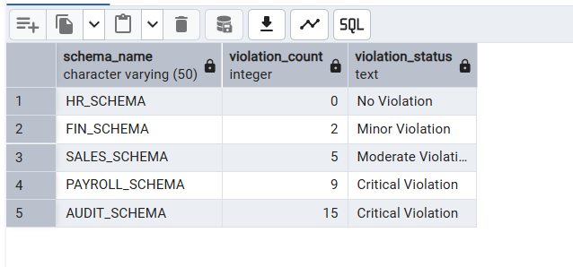

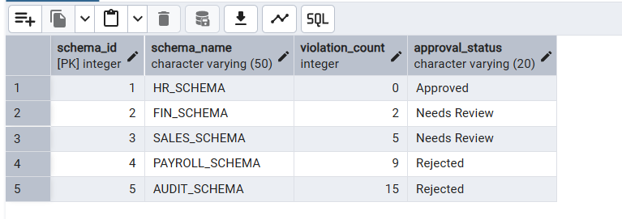

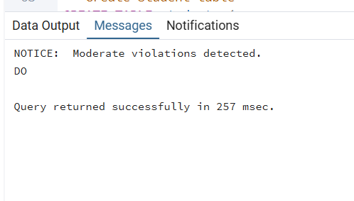

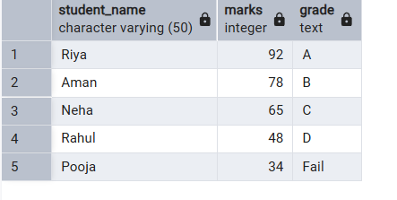

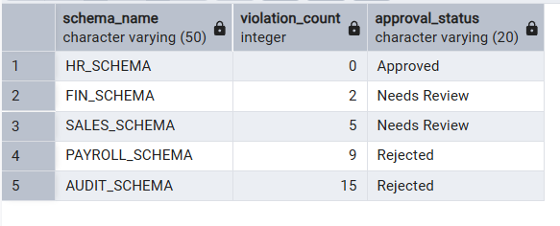

- Learning Outcome:
- Understand the use of conditional logic in PostgreSQL.
- Apply CASE expressions for data classification.
- Implement IF–ELSE logic using PL/pgSQL blocks.
- Perform rule-based decision making inside the database.
- Classify real-world data using multiple conditions.
- Automate validations without application-level logic.
- Use CASE expressions in SELECT, UPDATE, and ORDER BY clauses.
- Strengthen SQL skills required for backend systems.
- Gain confidence in interview-oriented SQL problems.
- Improve logical thinking for database-driven applications.

